**Name: _____________________ Date: ______________**



**YEAR: 11**

**SUBJECT: ATAR HUMAN BIOLOGY UNITS 1 AND 2**

**TEST: Foetal Development, Diagnosis of Foetal Health, Birth, Post Pregnancy Changes and Lactation, Contraception Methods and STIs.  
  
TIME: 60 minutes  
  
QUESTIONS: 20 Multiple Choice (20 marks)**

**6 Short Answers (32 marks)**

**1 Extended Response (15 marks)**

**TOTAL MARKS: 67 marks**

**Part A MULTIPLE CHOICE SECTION [20 MARKS]**

**Questions 1-20**

1. A lack of folic acid in a pregnant woman’s diet can lead to:
2. Abnormal bone growth
3. Still births and miscarriages
4. Neural tube defects
5. Abnormal cell growth
6. Which of the following genetic screening techniques allows for visual defects/abnormalities of the foetus to be determined?
7. Amniocentesis
8. Chorionic villus sampling
9. Maternal blood testing
10. Fetoscopy
11. Gamete Intrafallopian Transfer involves injecting what into the female’s reproductive system?
12. Eggs and sperm
13. Zygotes
14. Blastocysts
15. Donor sperm
16. The blastocyst is formed after the:
17. Second day
18. Fifth day
19. Eighth day
20. Eighth week

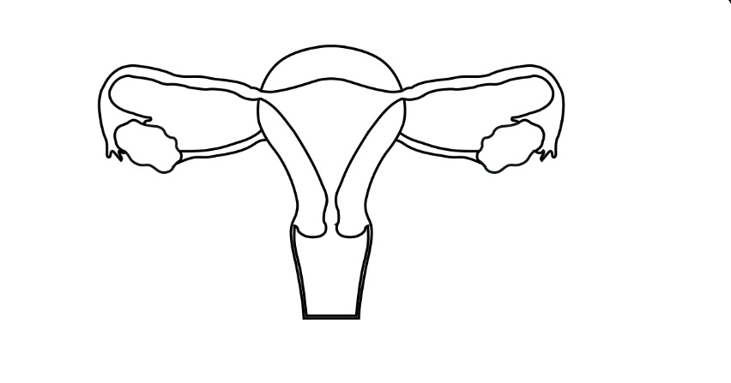

3

1. The optimum place of fertilisation is at point:
2. 1
3. 2

1

2

1. 3
2. 4

4

1. The third stage of labour involves the expulsion of the:
2. Foetus
3. Placenta
4. Placenta and membranes
5. Placenta, membranes and remains of the umbilical cord
6. Which one of the following tissue pairs develops from the same germ layer in a developing embryo?
7. Bone tissue and the epithelium of the digestive tract
8. Muscle and lung tissue
9. Brain tissue and the epidermis of the skin
10. Liver and nerve tissue
11. During childbirth, there are a number of key events:
12. Dilation of the cervix
13. Crowning
14. Delivery of the placenta
15. Breaking of the waters
16. Contractions of the uterus
17. Secretion of oxytocin
18. Delivery of the baby

Using the above, the normal sequence of events is:

1. vi, i, v, ii, iv, iii and vii
2. vi, v, i, iv, ii, vii and iii
3. i, ii, iv, vi, v, vii, and iii
4. vi, v, i, ii, iv, vii and iii
5. The placenta is the organ that allows for:
6. Mixing of maternal and foetal blood
7. Foetal blood to release oxygen to the maternal blood
8. Maternal blood to receive nutrients from the foetal blood
9. Foetal blood to receive nutrients from the maternal blood
10. A woman who has heavy scaring to her uterus and has had several miscarriages in the last few years wants to have a baby. Which reproductive technology would be best suited to her?
11. Artificial insemination
12. Donor embryo
13. In-vitro fertilisation (IVF)
14. Surrogacy
15. Gonorrhoea and chlamydia are both sexually transmitted infections caused by:
16. Bacteria
17. Viruses
18. Fungi
19. Parasites
20. Which of the following methods of contraception operates largely by preventing implantation rather than preventing fertilisation?
21. Diaphragm
22. Intra-uterine device
23. The oral contraceptive pill
24. Condom
25. A test that can be done during pregnancy to check for foetal abnormalities such as Down’s syndrome and other chromosomal errors is:
26. An ultrasound
27. Chorionic Villus Sampling
28. Fetoscopy
29. Foetal monitoring
30. Which of the following is NOT a potential outcome for the foetus, if the mother is smoking whilst pregnant?
31. Increased growth rate
32. Increased risk of SIDS
33. Reduced birth weight
34. Increased chance of respiratory disease
35. The Ectoderm germ Layer gives rise to which of the following structures:
36. Entire nervous system
37. Lymphoid tissue
38. Cardiac muscle
39. Epithelium of lungs
40. Which two structures give rise to the foetal and maternal placenta respectively?
41. Amnion and endometrium
42. Chorion and endometrium
43. Amnion and chorionic villi
44. Chorion and chorionic villi
45. The transmission of sexually transmitted infections such as AIDS, syphilis and gonorrhoea can be limited by:
46. Oral contraceptive pill
47. Spermicide
48. Condoms
49. Intra-uterine devices
50. The hormone responsible for the milk letdown and uterine contractions during labour is:
51. Progesterone
52. Oestrogen
53. Oxytocin
54. Prolactin
55. The ductus venosus diverts foetal blood away from the:
56. Lungs
57. Liver
58. Placenta
59. Left ventricle
60. Which of the following is not a form of hormonal contraception?
61. Femidom
62. Mini pill
63. NuvaRing
64. Mirena IUD

**Year 11   
ATAR  
Human Biology**

**MULTIPLE CHOICE ANSWER SHEET**

For each question, shade the box to indicate your answer. Use only a blue or black pen to shade the boxes. If you make a mistake, place a cross through that square then shade your new answer. Do not erase or use correction fluid/tape. Marks will not be deducted for incorrect answers. No marks will be given if more than one answer is completed for any question.

|  |  |  |  |  |
| --- | --- | --- | --- | --- |
| **1** | a | b | c | d |
| **2** | a | b | c | d |
| **3** | a | b | c | d |
| **4** | a | b | c | d |
| **5** | a | b | c | d |
| **6** | a | b | c | d |
| **7** | a | b | c | d |
| **8** | a | b | c | d |
| **9** | a | b | c | d |
| **10** | a | b | c | d |
| **11** | a | b | c | d |
| **12** | a | b | c | d |
| **13** | a | b | c | d |
| **14** | a | b | c | d |
| **15** | a | b | c | d |
| **16** | a | b | c | d |
| **17** | a | b | c | d |
| **18** | a | b | c | d |
| **19** | a | b | c | d |
| **20** | a | b | c | d |

**PART B: SHORT ANSWER SECTION (32 marks)**

21. (a) Fill in the following table regarding the given contraceptive methods (4 marks)

|  |  |  |
| --- | --- | --- |
|  | Advantage | Disadvantage |
| Rhythm method |  |  |
| Vasectomy |  |  |

(b) Is it possible for a man who has had a vasectomy to pass on the sexually transmitted infection HIV to his partner? Explain your answer. (2 marks)

__________________________________________________________________________________________________________________________________________________________________________________________________________________________________________________________________________________________________________________________________________________________________________________________________________________

22. On the diagram of foetal circulation below, there are 2 structures labelled (a) and (b) that change within a child after birth.

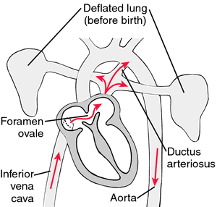

a.

b.

1. Name both of the structures in the space provided below. (2 marks)
2. a = _____________________________________________
3. b = _____________________________________________

(b) There is a 3rd structure, not present in the diagram, that is also no longer needed by the baby after birth. Give the name of this structure and state its function in the developing foetus. (2 marks)

________________________________________________________________________________________________________________________________________________________________________________________________________________________

23. The following questions refer to the diagram below.

**i.**

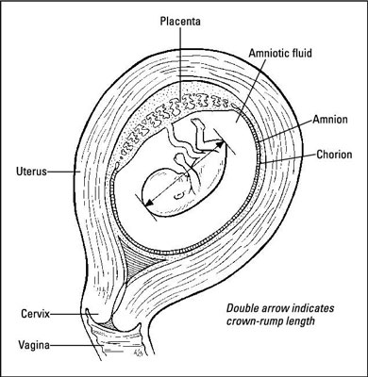

**ii.**

**iii.**

**iv.**

(a) What is the name of structure (i)? List 2 of its functions. (3 marks)

________________________________________________________________________________________________________________________________________________

1. Structure (ii) can be used for genetic screening purposes. State the name of this screening technique and give an example of what it would test for. (2 marks)

________________________________________________________________________________________________________________________________________________

24. During pregnancy it is very important to avoid exposure to teratogens. Some examples of teratogens are chemicals such as thalidomide and mercury. Define the term teratogen and give two other examples of teratogens. (3 marks)

________________________________________________________________________________________________________________________________________________________________________________________________________________________

25. Stem cells are used for research all around the world with limited implications and ethical issues. They can be sourced from 3 main places. Name where they are sourced from, the type of stem cell they are and then provide one positive implication for their use. (9 marks)

|  |  |  |
| --- | --- | --- |
| **Source** | **Stem cell classification** | **Positive to using this type** |
|  |  |  |
|  |  |  |
|  |  |  |

26. Infertility refers to the biological inability of a person or couple to conceive under natural conditions. Some types of infertility can be overcome with in-vitro fertilization (IVF). Explain the procedure used in IVF. (5 marks)

________________________________________________________________________________________________________________________________________________________________________________________________________________________________________________________________________________________________________________________________________________________________________

**PART C: EXTENDED ANSWER SECTION (15 Marks)**

The process of birth or parturition involves 3 separate stages. In the space provided below:

* Name the different stages.
* Explain when they begin/end.
* Duration of each stage.
* Steps involved in each stage.

|  |
| --- |
|  |
|  |
|  |
|  |
|  |
|  |
|  |
|  |
|  |
|  |
|  |
|  |
|  |
|  |
|  |
|  |
|  |
|  |
|  |
|  |
|  |
|  |
|  |
|  |
|  |
|  |
|  |
|  |
|  |
|  |
|  |
|  |
|  |
|  |
|  |
|  |
|  |
|  |
|  |
|  |
|  |
|  |
|  |
|  |

**END OF TEST**